COMP206-Internet

Multiple Processes that work together

In principle, spreading computation across N computers gives the possibility for an N-fold increase in computing power. Finish jobs in 1/N of the time.

In practice, due to communication delays, congestion, waiting, it can be difficult to get any speedup.

It is even possible to design a distributed system that never completes!

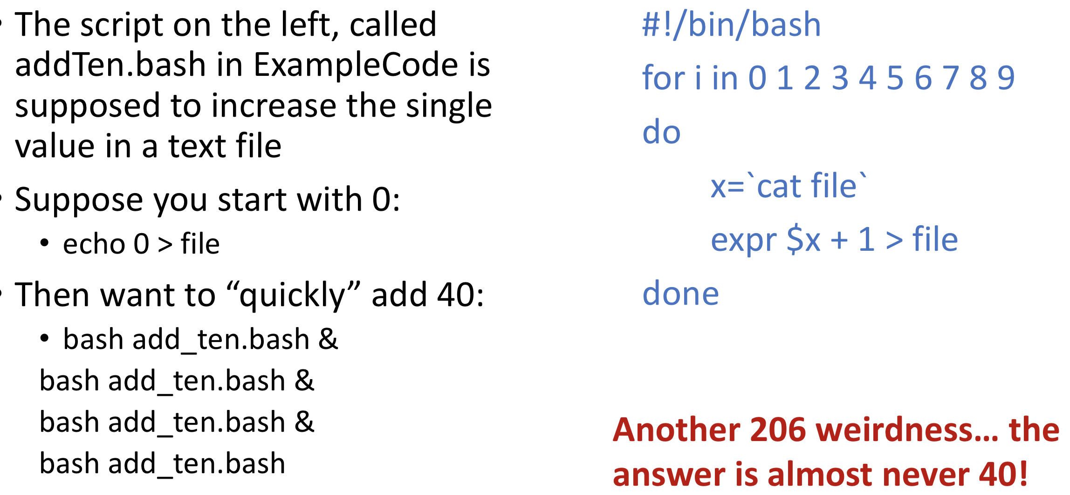

Web Browser as a Software System

Q: You see rendered HTML including images, UI elements, color. How did this get there?

A: Your *browser* communicates with the *server* that provides the content. It has functionality to display a user interface that interprets the data received in a useful way and send requests for new content when you, for example, click a link

A *server* is on the other end making this transaction complete.

The server holds the information and passes it to your browser when requested.

* This can be a single-shot: mcgill.ca homepage
* This can be on-going: play a movie

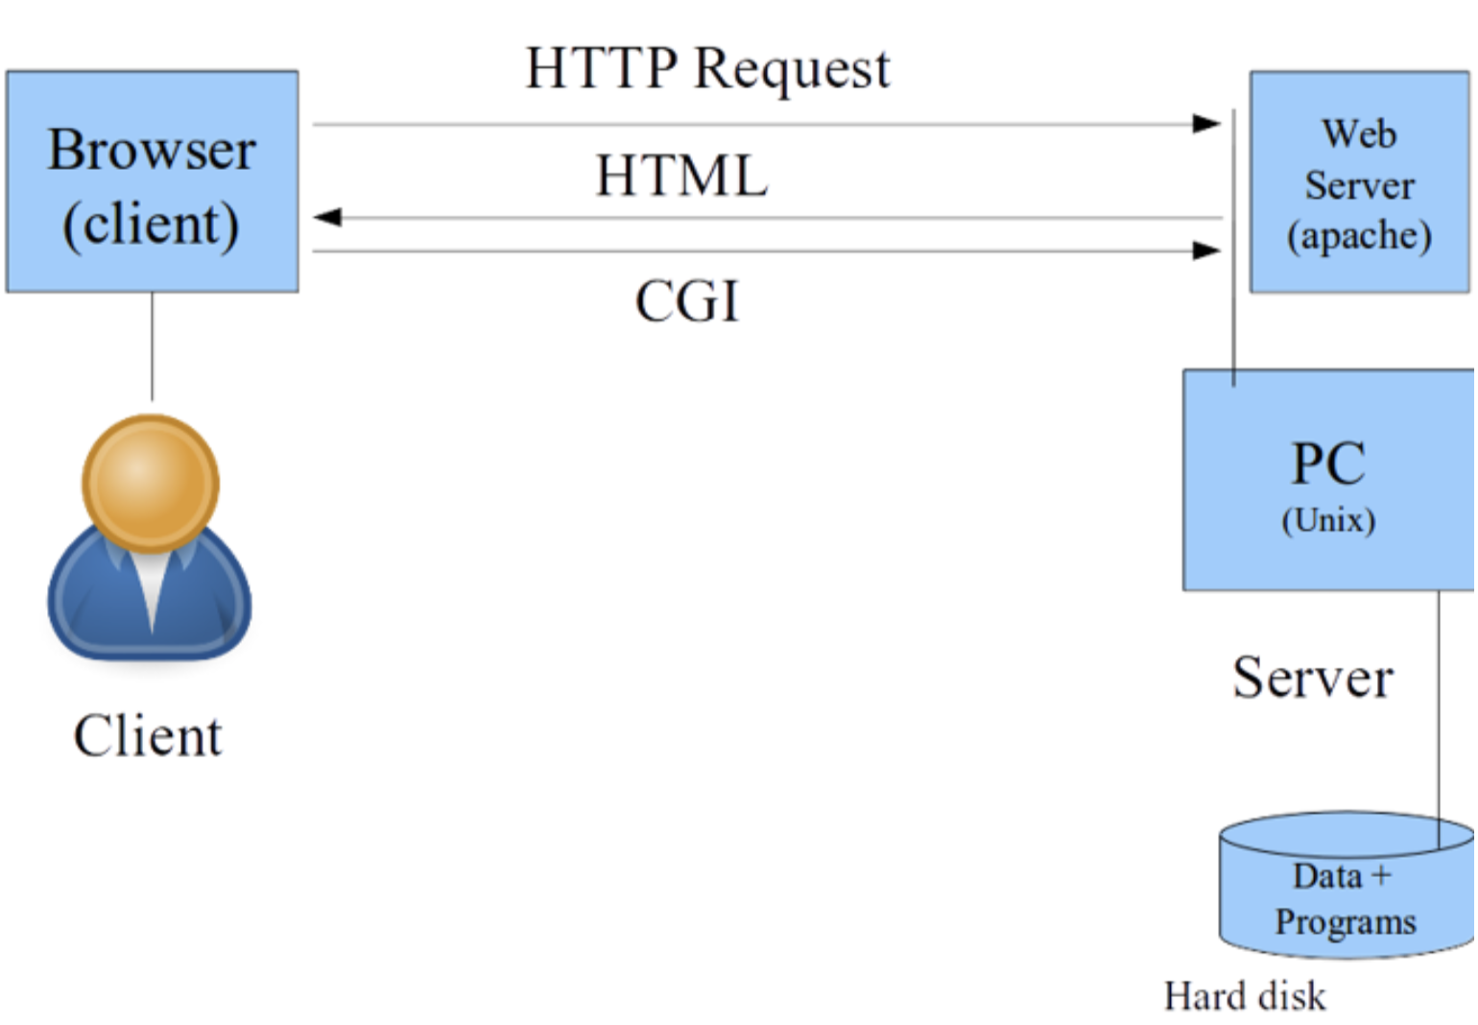

Internet traffic is not guaranteed because:

• The other end-point can have a failure (user ctrl-c, power turned off, etc)

• There are many devices in between the end-points. They can be busy, malfunction, be turned off, etc.

• There are physical connections involved: copper cables, fibre, radios transmitting Wifi signals. Each of these has the potential to fail.

As a result, the Internet is a Best Effort transmission medium and our software system code must be prepared for this situation.

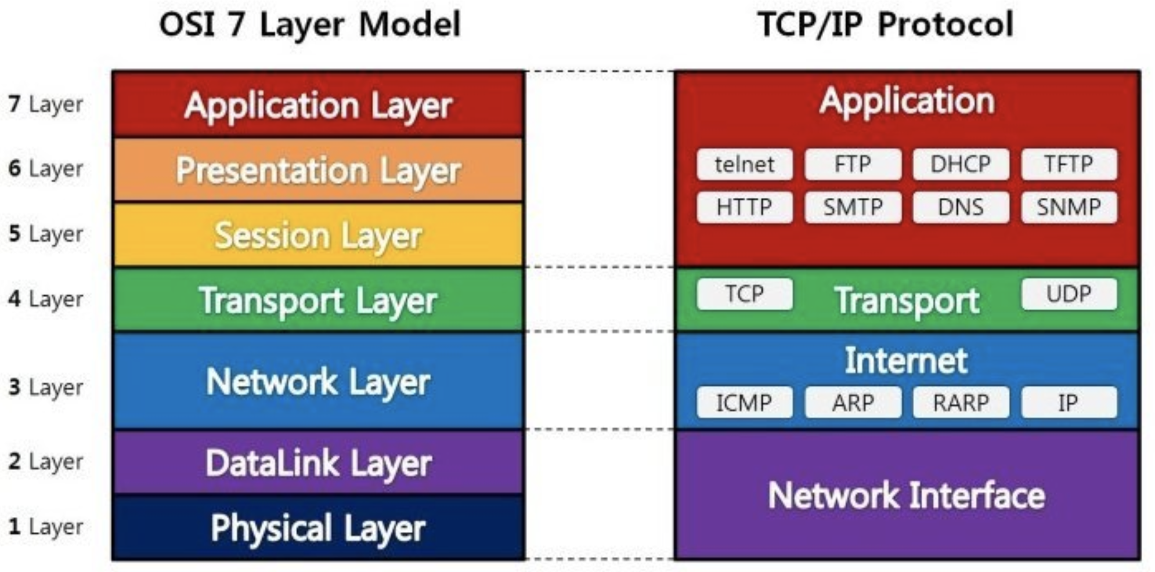

*The Network Layer: Internet Protocol*

• The network layer provides functionality to get data across the world by bundling it into datagrams (aka packets) that are stamped with crucial information to allow transmission

• Addresses of the source and destination. IP addresses can be 32-bit (IPv4) or 128-bit (IPv6).

• Message length field (helps to ensure we've sent everything)

• Time-to-live (helps to find out if the Internet has a cycle: It can happen!)

• Header checksum (protects against errorful transmission)

*The IP Header Checksum: bit operations!*

• The checksum field is the 16-bit one's complement (negation) of the one's complement sum (handling overflow) of all 16-bit words in the header. For purposes of computing the checksum, the value of the checksum field is zero.

• The result of summing the entire IP header, including checksum, should be zero if there is no corruption.

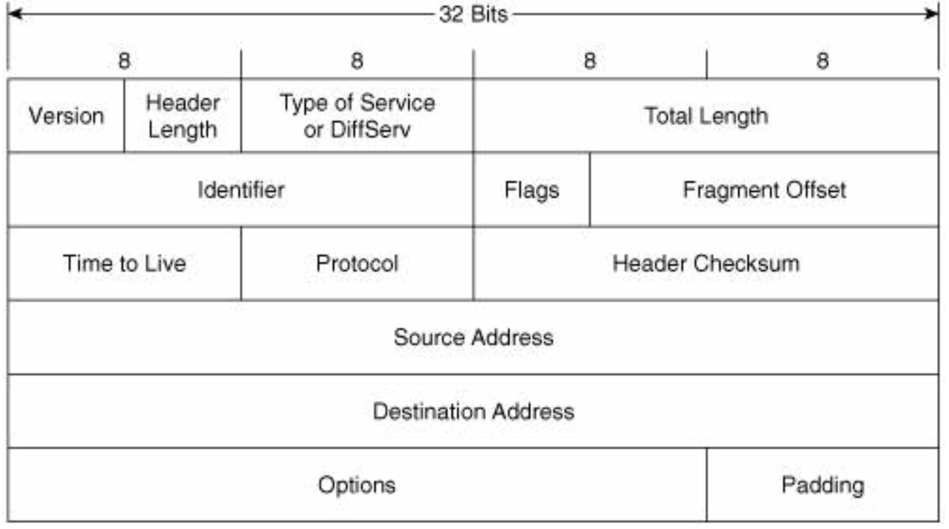

*Transport Layer: Transmission Control Protocol (TCP)*

• TCP provides reliable, ordered, and error-checked delivery of a stream of bytes between applications running on hosts communicating by an IP network.

• TCP is the main way that the internet attempts quality control. Several tools are used in combination to achieve this:

• Sequence numbers: each packet in a stream of data is numbered

• Acknowledgements: receiver confirms receipt

• Re-transmission requests: in case of missing data detected

• Congestion control: avoid being too chatty (very important!)

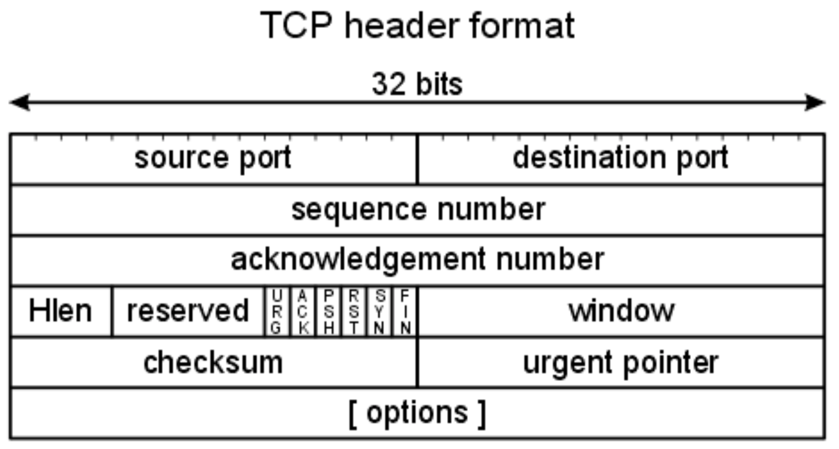

*High-level Layers: Applications*

These are the things we see every day:

• HyperText Transfer Protocol: The web!

• Secure shell: connecting to servers

• File Transfer Protocol

• SMTP: Email

• DHCP: Obtaining an address on the network

• DNS: Looking up computers with convenient names

*Linux and C provide us an interface to the Internet that is called* ***Sockets****, so that we can write end-point code such as chat clients, web browsers, web servers, video streams, phone apps, etc.*

[UNIX Socket: Functions]

* socket() : Create a socket, specify it’s protocol type (AF_INET)
* bind() : Specify the coordinates: address and port number
* listen() : Wait for someone to respond, the OS does all the checking
* accept() : If someone is there, acknowledge and start the comms
* read() : Just like a file, put data into the socket
* write() : Just like a file, get data out of the socket

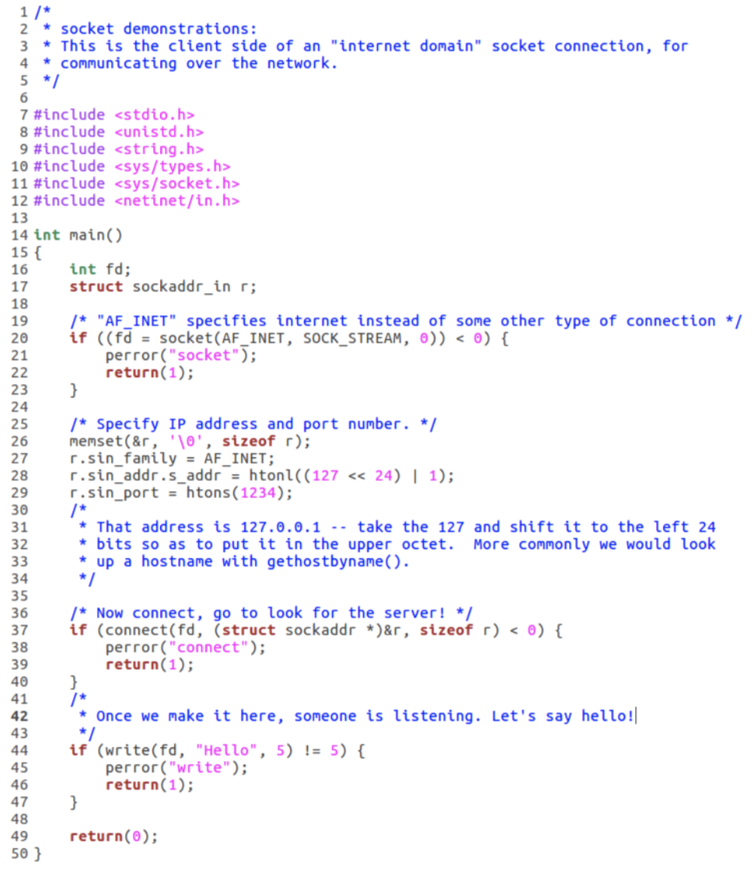

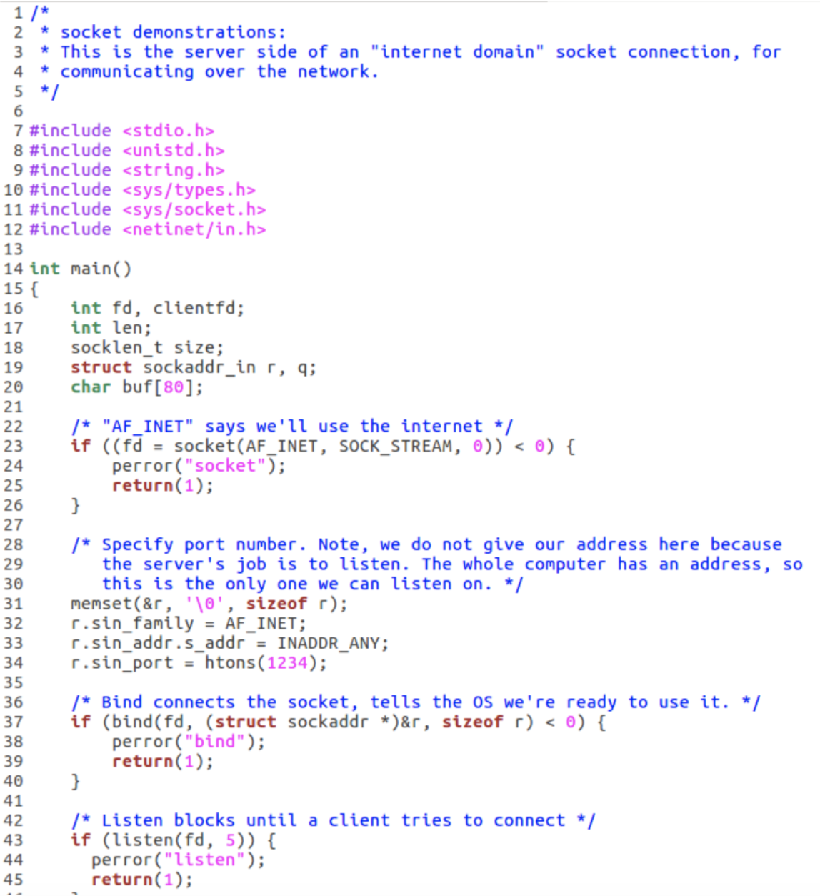

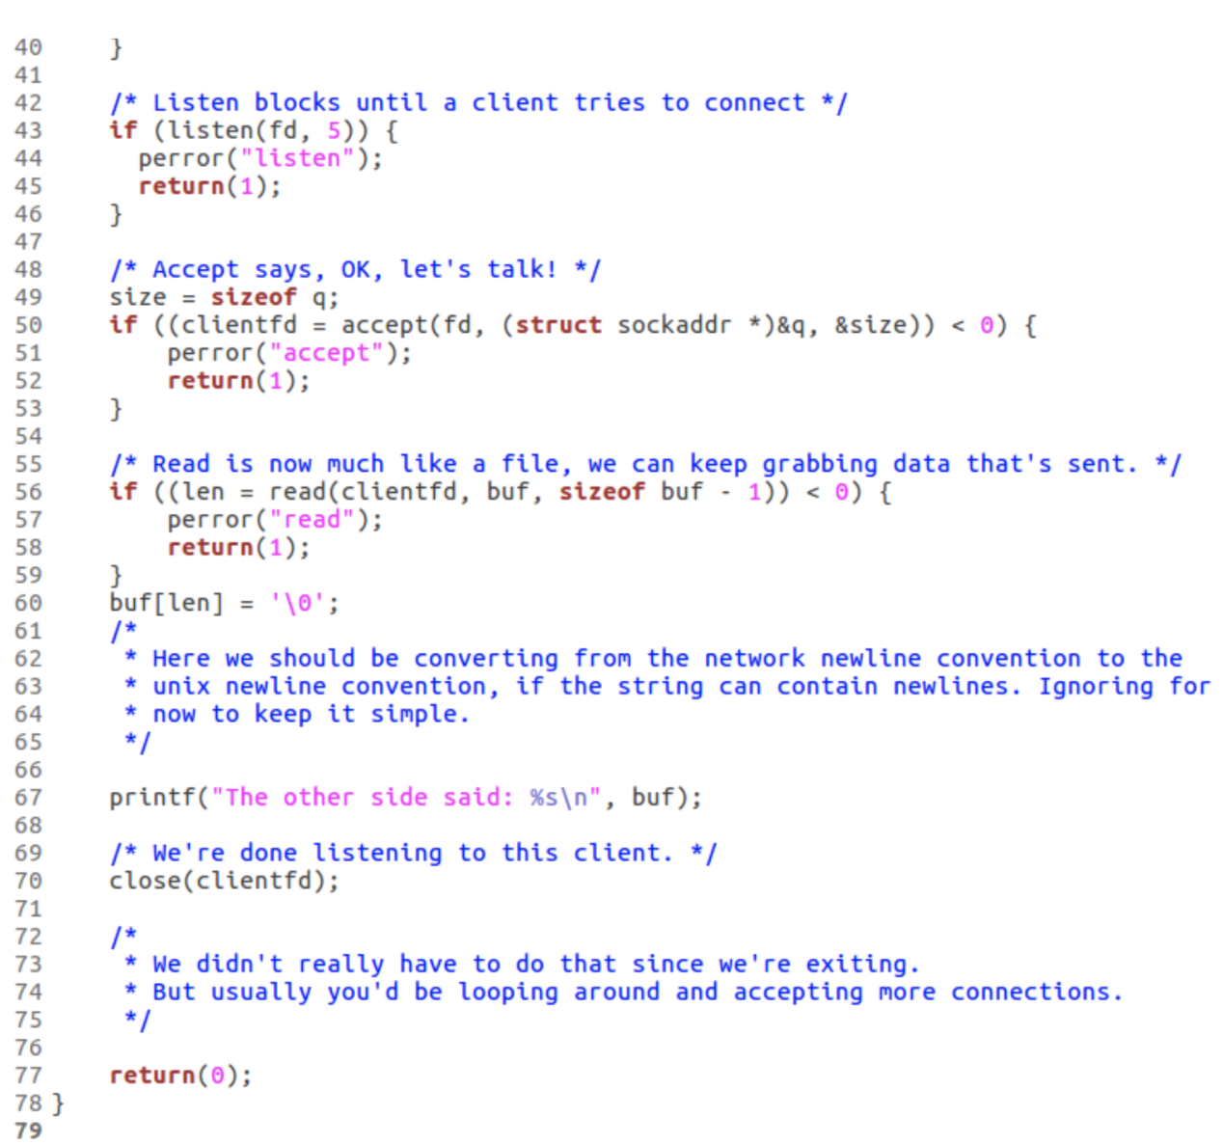

How to keep track of all of these **addresses**?

* IPv6 allows close to 2128 devices to be online and uniquely addressable:

• Log in to every device from your laptop to your toaster!

• Each address is 16 bytes... hard to even type correctly, let alone remember!

* Routers and servers are organized into a hierarchy and direct traffic
* Domain Name Service (DNS) is the book-keeper:

• Each human readable name is mapped to a unique address (it can change over time)

• Each computer and server can offer name resolution, the ability to look-up addresses in the part of the internet that it's responsible for

The DNS Hierarchy

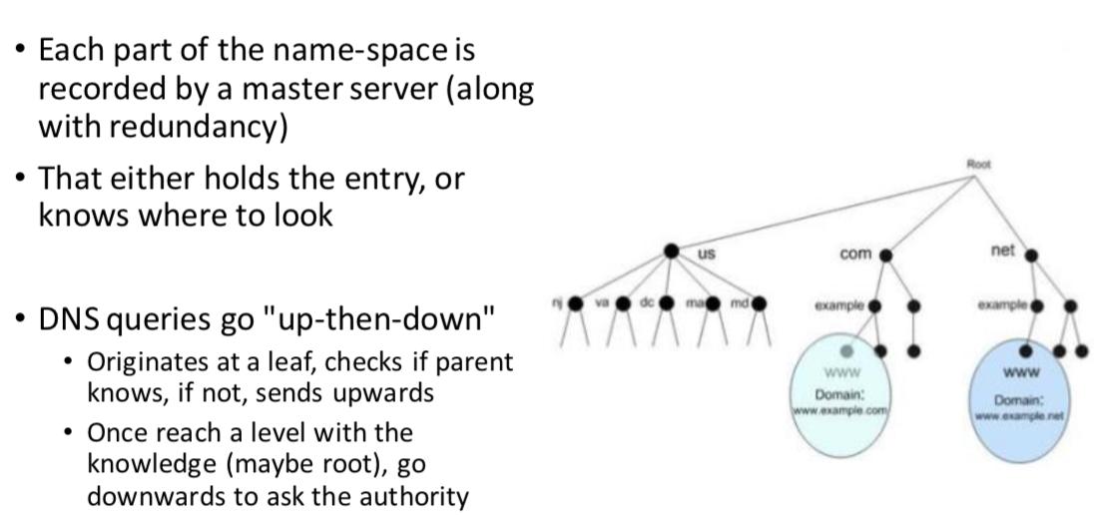

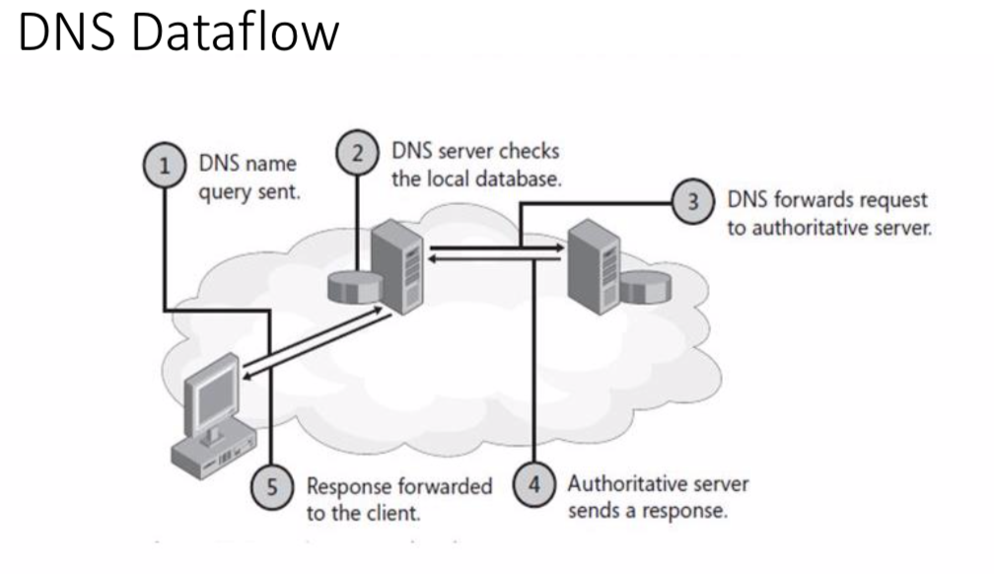

[Networking Tools in Linux]

*Commands:*

* ssh, ftp, scp, etc : Command-line networking
* ifconfig : Report on network interfaces
* ping : Send trivial packets to <source>, useful to look-up DNS addresses • iwconfig : Manage wireless connections
* iptables, route, etc : Turn your PC into a network traffic switch

*Security:*

* Enforced through protected port ranges, optional firewalls (e.g., ufw), user authentication (e.g. LDAP)

Beyond Addresses: **Ports**

A computer must often maintain multiple connections

• E.g. A web server streaming video to multiple users

• E.g., Any computer at all since so many apps and resources live on the "cloud" currently

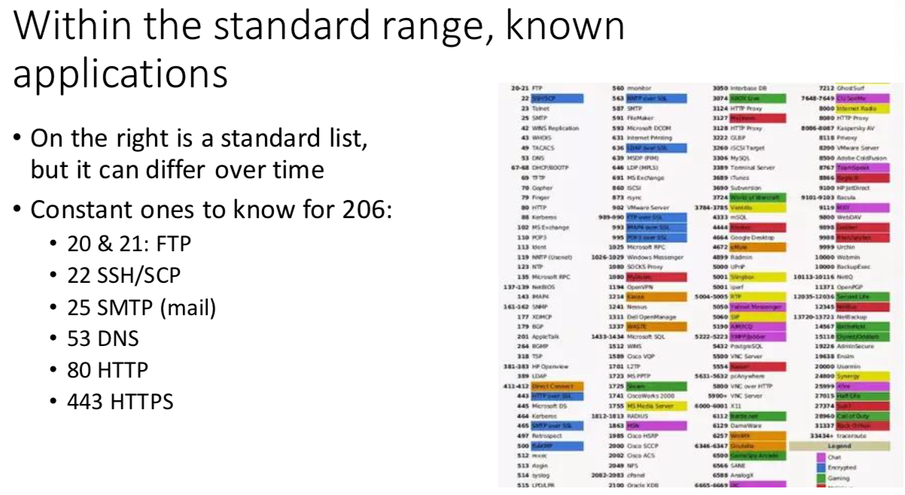

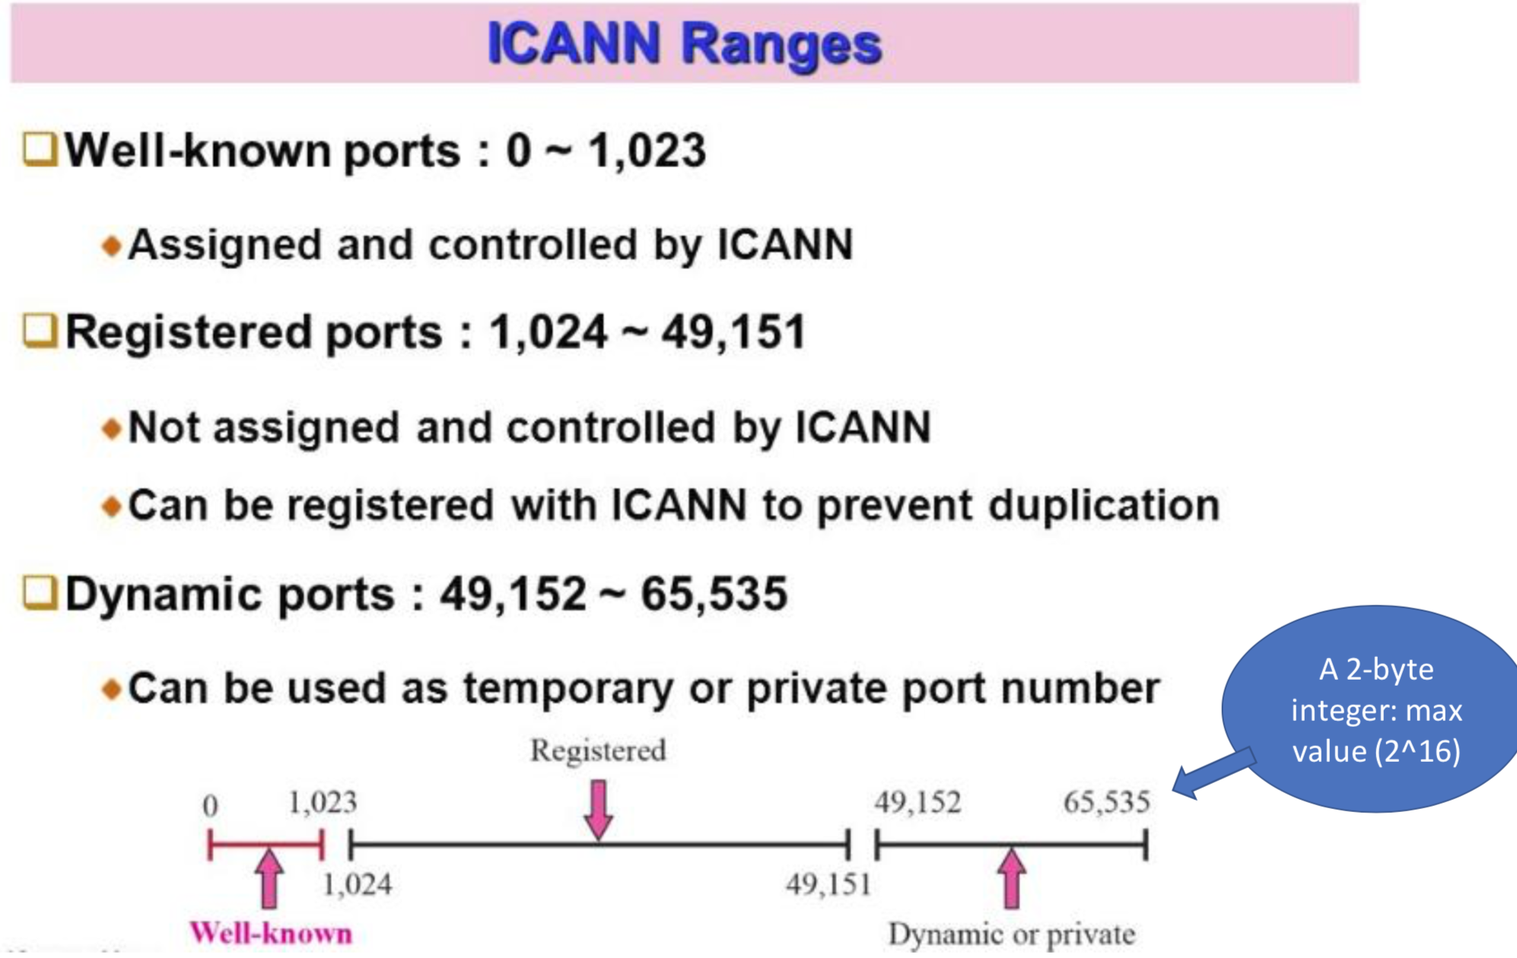

Which ports can I access?

• Access to ports enables the good internet functionality that we want, but it's also an opening for unwanted access

• A *"firewall"* is a software system designed to monitor internet communication and restrict dangerous activities.

• Firewalls can be implemented in the backbone, such as in a wifi router or McGill's central internet connection, as well as by each end-point device (client and server)

Typical **firewall** restrictions

• It is common that all ports outside those used for named applications are closed to traffic outside the "trusted" network

• For McGill, this can mean some functions do not work connecting to mimi from home.

VPN'ing is one way to fix this, it means your computer is now "virtually" part of the trusted network, but it still may not allow everything

• Because we cannot entirely change the networking settings everywhere, we oftentimes use "localhost", or 127.0.0.1 to demonstrate low-level functions. Do not be fooled, this still uses the "internet", but only the local implementation on a single computer.

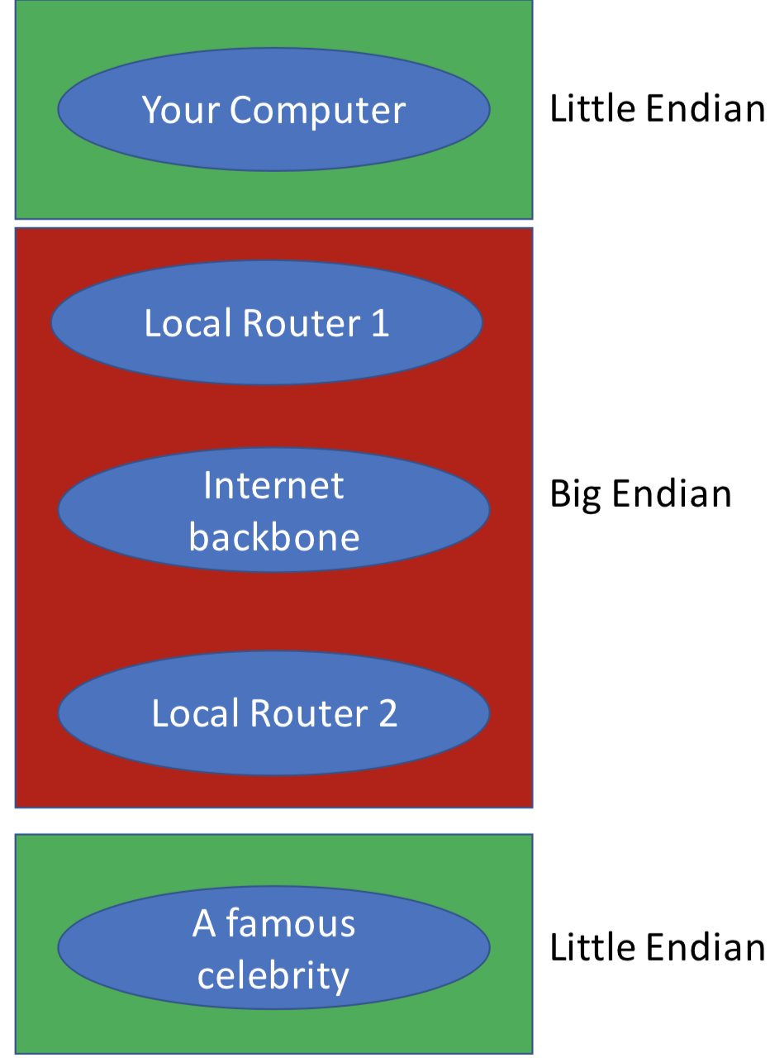**Standardize Endianness on the Internet**

• Each device that hops our traffic through the internet needs to read the destination address to decide where to send the packet next

• What if those computers do not have the same endianness?

Therefore, we must choose a standard: Big Endian is "network byte order". Everyone converts to that when the message is sent

short



long



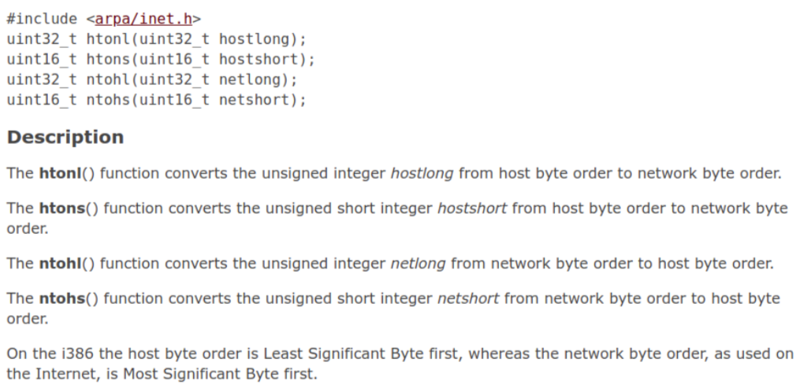

What else must be standardized?

* \0 ends C strings
* \t means tab
* \r\n is the network “newline”

\n means newline (or does it?)

\r means carriage-return (which carriage?)

**Connection**

The Internet's idea is "best effort" in that we will always acknowledge the possibility of failure and move on eventually.

**TCP phase**

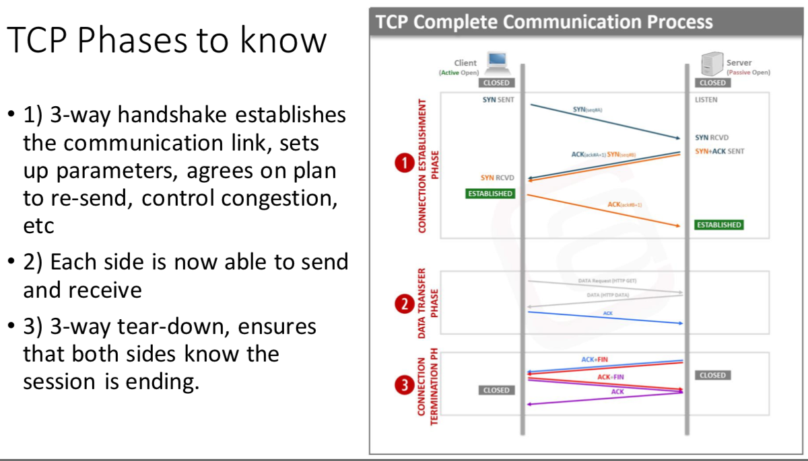

Example: echo_server and echo_client in ExampleCode/Lecture18

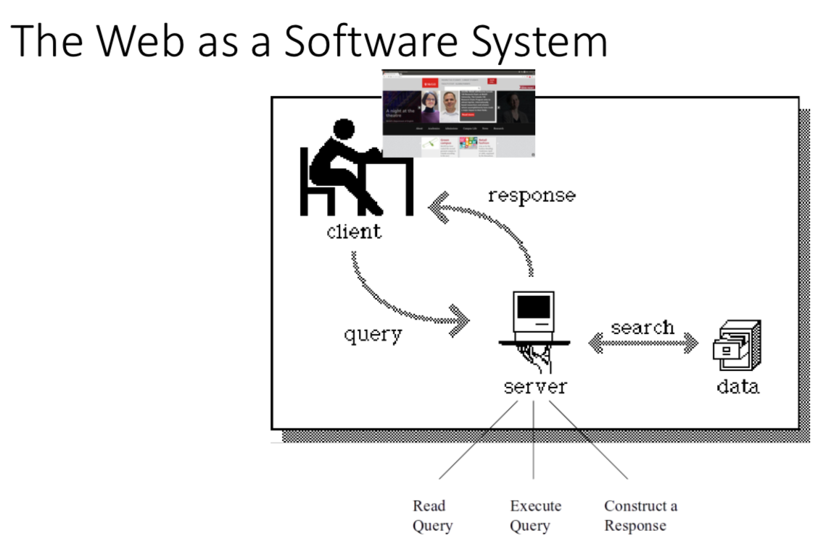

**World Wide Web**

The web is one of the most pervasive application-level software systems on the internet

It's formed out of a collection of quite simple protocols that everyone can easily implement, so that many people, companies, governments, etc can interoperate even without using the same software:

• Many browsers: chrome, safari, edge, lynx

**Web Software Protocols**

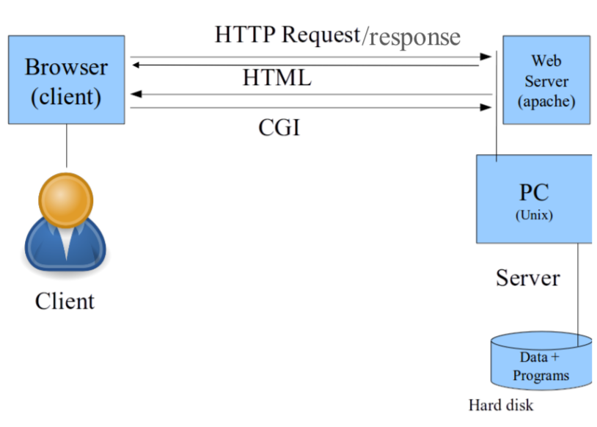

**Overview of Web Protocols**

* + HyperText Transmission Protocol (HTTP) : the backbone for web inter- connections. Describes how to request and interpret basic web data
  + Hyper Text Markup Language (HTML) : the basic building-block of web pages. Text, formatting, colors, images, extensible components for new ideas (3D graphics, UIs, etc)
  + Common Gateway Interface (CGI) : A protocol to allow server-side programs to be run through web interactions, producing output that drives subsequent interactions
  + Many more elements now exist on the client side: javascript, css, flash, mobile application eco-systems, and many more (not for 206)

[HyperText Transfer Protocol (HTTP)]

TCP/IP allows end-points to transfer arbitrary binary data streams. This is like giving the computer a mouth and ears, but without a language, how can we write code that accomplishes anything? HTTP is the "language" of web connections. It lets browsers ask for web content and lets servers provide it. It is an open, evolving, community-defined standard that all web entities use to structure their transmissions so that each side can understand:

[HTTP and Networking]

* + HTTP's job is to allow clients to request the resources they desire and to allow servers to respond appropriately.
* It lives on top of lower network layers. The request and response are plain-text payloads with a specific format that must be transmitted somehow (of course we all use TCP/IP, through sockets!)
  + A HTTP client establishes a connection over a predefined port :

• 80 for normal HTTP

• 443 for SSL HTTP (secure)

* + An HTTP server sits waiting on the port, parses the client request and responds (perhaps on a different port, but let's ignore that for now)

[HTTP Requests and Responses]

* + Client starts the communication by sending an HTTP request that includes a **METHOD, Uniform Resource Identifier (URI)**, protocol version, and header:
  + The most common method is GET, this means "Send me back the page"
  + The server sends back a response code, response text, header, followed by the requested data, if any. Common response codes:

• 200: OK

• 401: Unauthorized

• 403: Forbidden

• 404: Not Found

• 500: Internal Server Error

[URI vs URL]

We are used to typing Uniform Resource Locators (URLs) into our web browser. They include:

* + the server name/address,
  + optionally, the port if we care to switch away from the default 80/443 (separate by colon, like mimi.cs.mcgill.ca:5000)
  + and then describes the path to a file on that server.

The URI can be the portion only after the server address and port, while the URL must include all of the above

* + It makes sense only to need to URI within an HTTP request, because we are sending this data to a server on a port (full URL re-dundant). Unless the server is having an identity crisis (midterms are hard ok!)

HTTP session Example

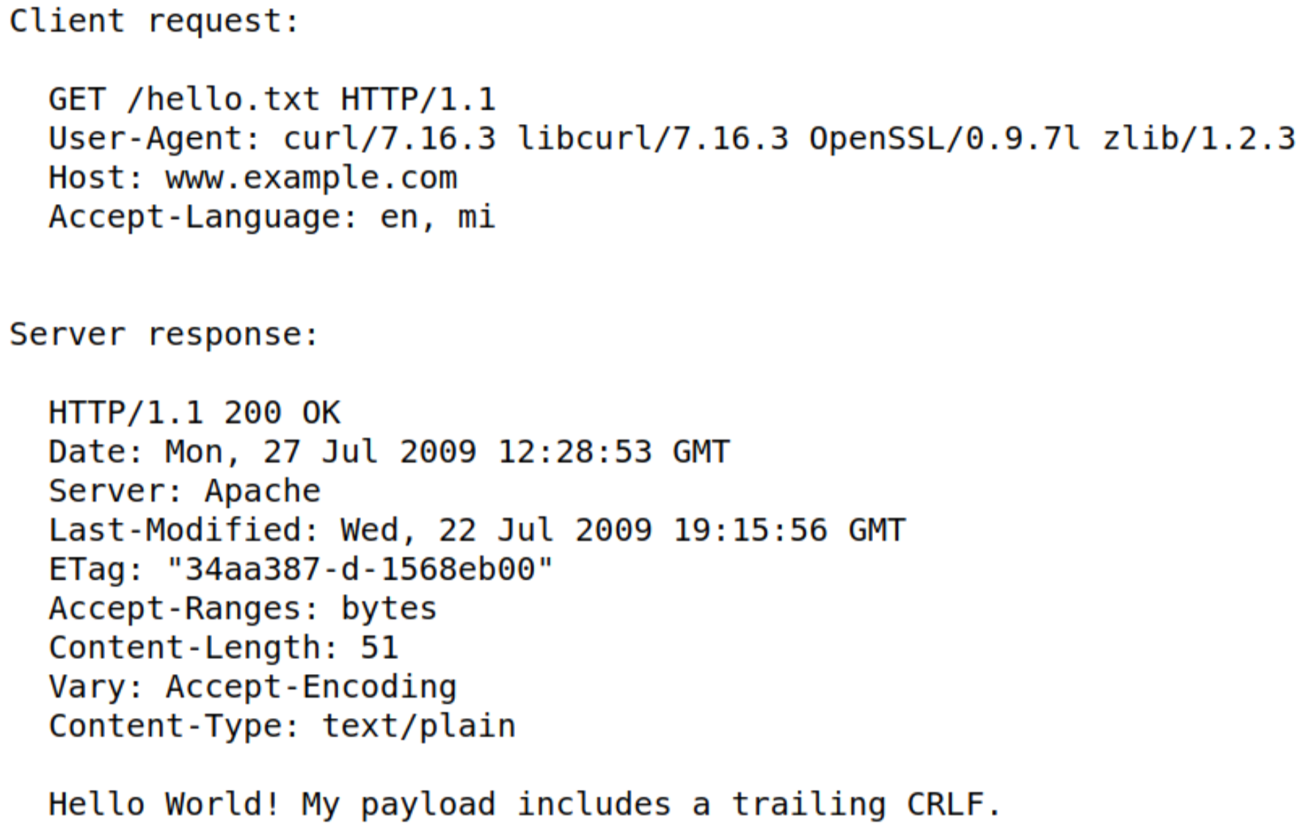

[Hyper Text Markup Language (HTML)]

An example of formatted text

*An HTML document is made up of tags with content.*

Examples: • <html></html> encloses the full document

• <body></body> encloses the main content of the page

• <a></a> encloses information about a link

Each tag can also have arguments. e.g. <a href="http://cs.mcgill.ca>

HTML is a convention that allows many web authors and many web browsers to see the web in a consistent way. But is not actually connected much with HTTP and the code that runs the web, so it's not a focus for 206 (although we will mess with it a bit when we write CGI functions)

Web Browser as a Software System

You see rendered HTML including images, UI elements, color. How did this get there?

Your browser is making HTTP Requests and reading the Responses:

• Started each time you enter a URL or click a link

• Parses the response (HTML page, image, etc) and displays what's appropriate

The other Side: web server software

A website is accessible because some computer is running persistent server code waiting for browsers to connect

• The server holds the data (HTML pages, images, programs, etc)

• Upon a connection, searches for the most appropriate response and returns the payload

[A Web Browser in C: pseudo-code]

• Required to initiate the socket communications: socket() and connect() • Provide the server's address and use port number 80

• Required to form the HTTP Request. This is just a simple C string: • char *request = "GET / HTTP1.1"; (if we want to get the index.html)

• Send with write() onto the socket

• Wait for the response and gather it using read() from the socket

• Display information received if the code was OK, else tell the user the error

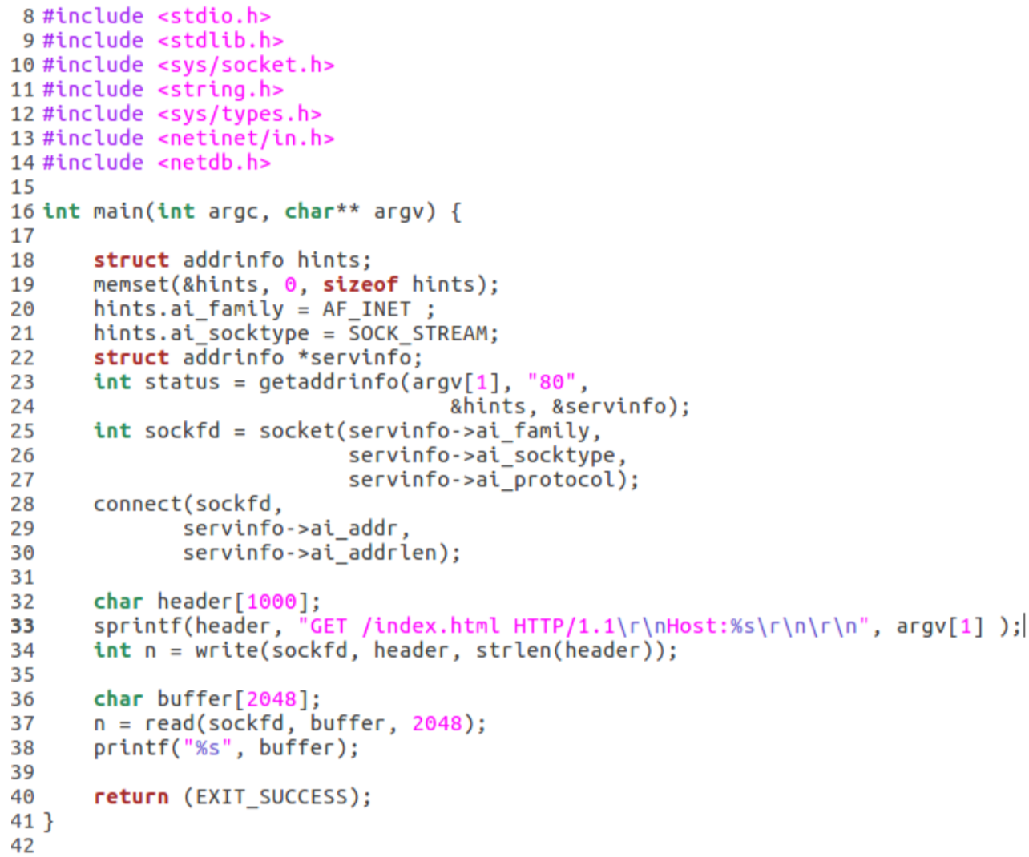

Loop forever awaiting connections, when one arrives:

• Read the HTTP request, depending on the command and URI:

• Perhaps look up a page on the local disk, read it into memory

• PerhapsexecuteaCGIbyformingthecorrectstdin,captureitsstdoutinmemory(thisto be covered in the next set of slides!)

• Perhaps prepare an error response as a nicely formatted HTML page in memory

• Write the HTTP response back to the client, forming the correct header and placing whatever we assembled in memory into the body

Web Server Example: "httpd.c" in the Lecture19 folder in ExmapleCode

**Coordination**

Tie-breaking with *semaphores*

Idea: have a central agent (the operating system) keep track of who asked first and only let one process execute at a time.

The process that asks first gets to proceed right away, and must then also say when it's finished. All other processes are blocked by the central agent, and allowed to proceed one at a time.

*A semaphore is an object that consists of a counter, a waiting list of processes and two methods (e.g., functions): post and wait .*

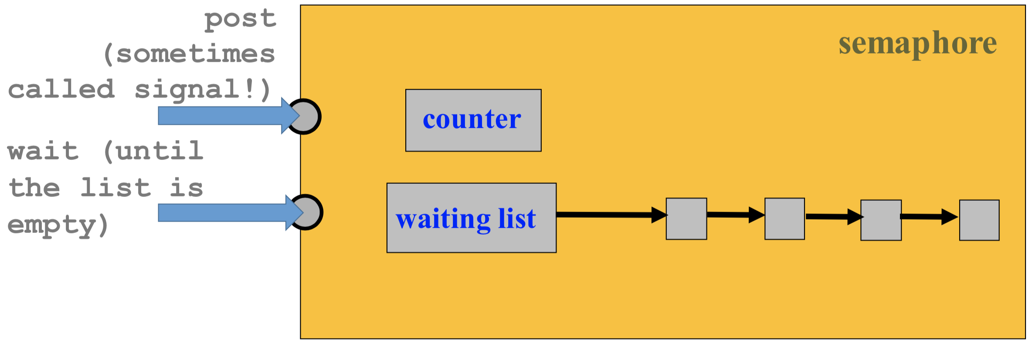

*semaphore method: wait*

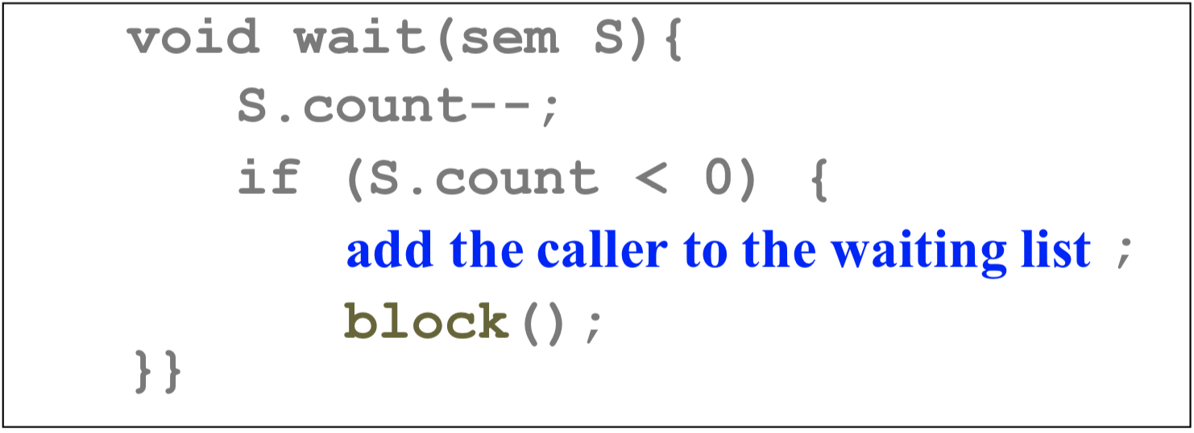

After decreasing the counter by 1, if the counter value becomes negative, then add the caller to the waiting list, and then block the caller. If all processes call wait(), only "the initial value of count" can run at once!

If we only want to execute one process at a time, set the initial value of count to be 1.

*Semaphore Method: post*

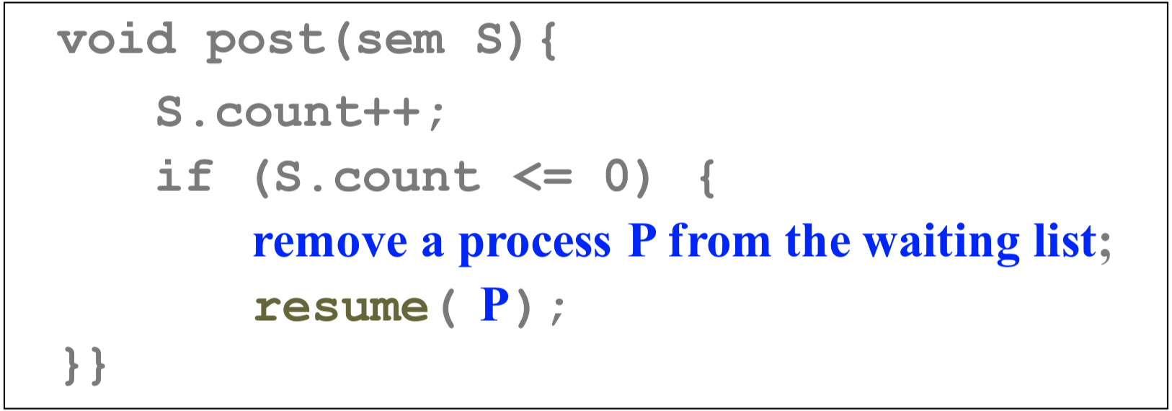

After increasing the counter by 1, if the new counter value is not positive, then remove a process P from the waiting list, resume the execution of process P, and return recall wait() let only "initial count" jobs start. **Post means "I finished", the next in line can start.**

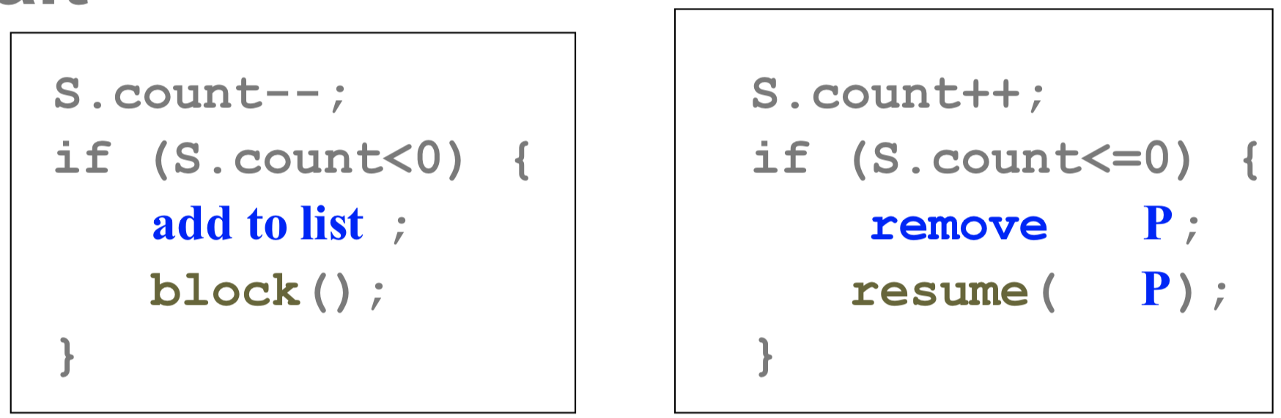

* **If S.count < 0, abs(S.count) is the number of waiting processes.**

This is because processes are added to (resp., removed from) the waiting list only if the counter value is < 0 (resp., <= 0).

* **The waiting list can be implemented with a queue if FIFO order is desired.**

However, the correctness of a program should not depend on a particular implementation of the waiting list. Your program should not make any assumption about the ordering of the waiting list.

* The caller may be blocked in the call to wait(). The caller never blocks in the call to post(). If S.count > 0, post() returns and the caller continues. Otherwise, a waiting process is released and the caller continues. In this case, two processes continue.
* **wait() and post() must be executed atomically (i.e., as one uninterruptible unit**, once I call wait()/post(), no other process will be executed until wait() finished). Otherwise, *race conditions* may occur.

[Three Typical Uses of Semaphores]

There are three typical uses of semaphores:

* **mutual exclusion**: Mutex (i.e., Mutual Exclusion) locks
* **count-down lock**: Keep in mind that semaphores have a counter.
* **notification**: Indicate an event has occurred.

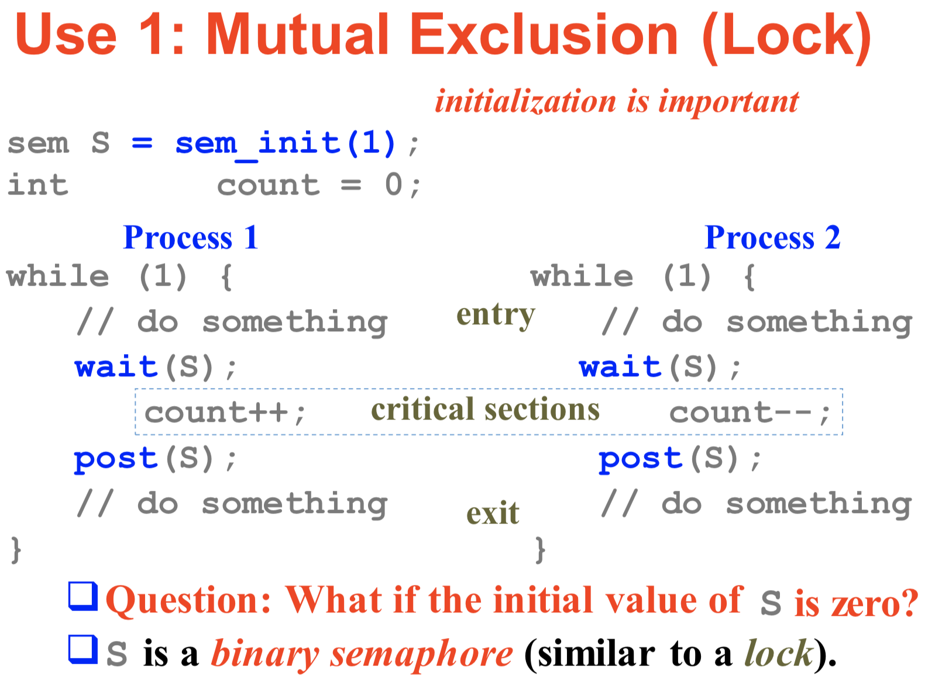

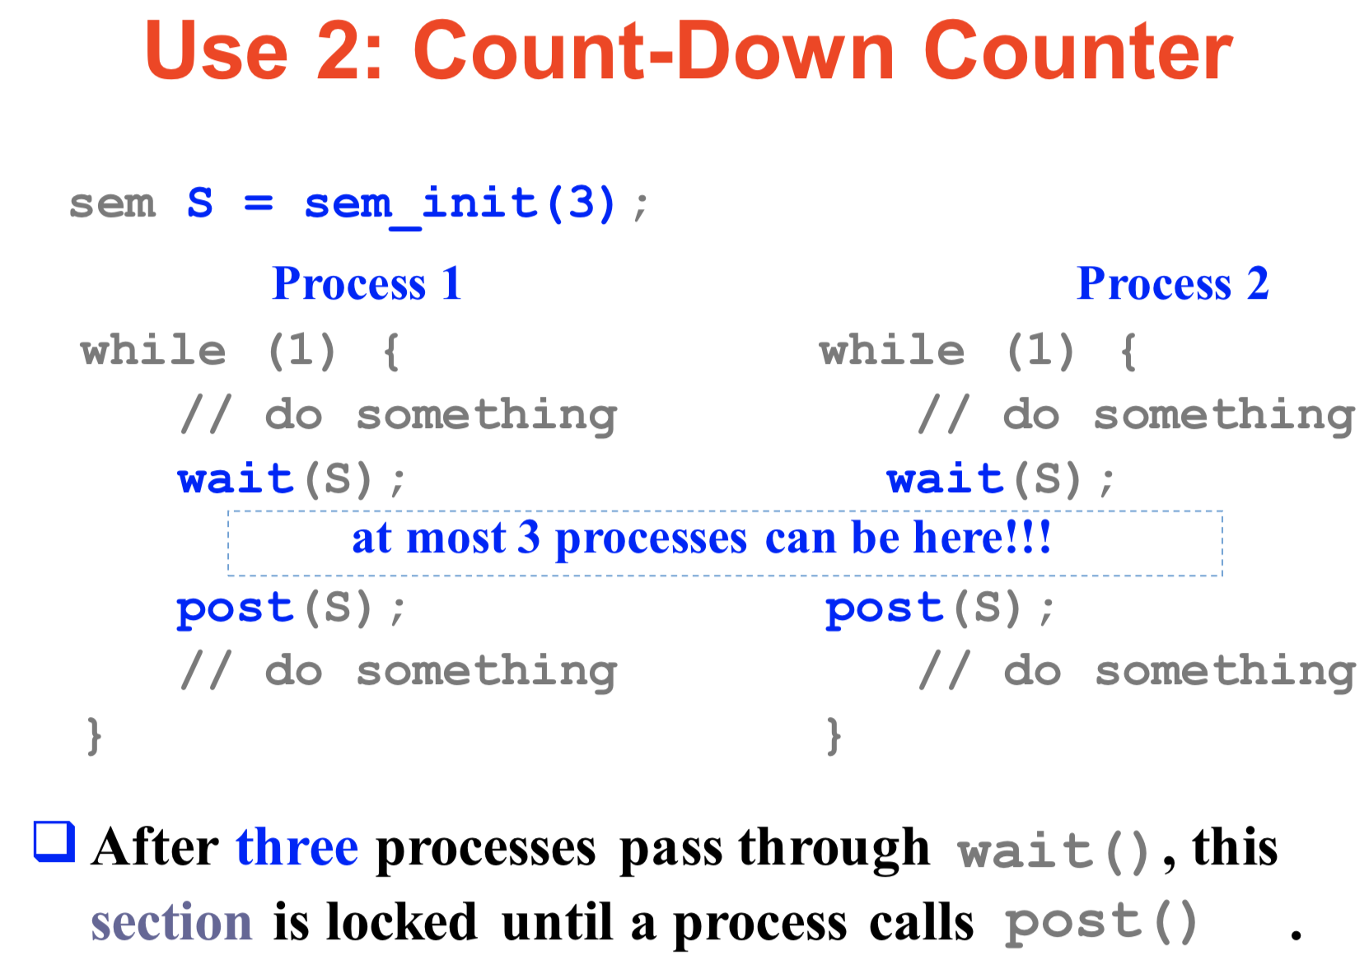

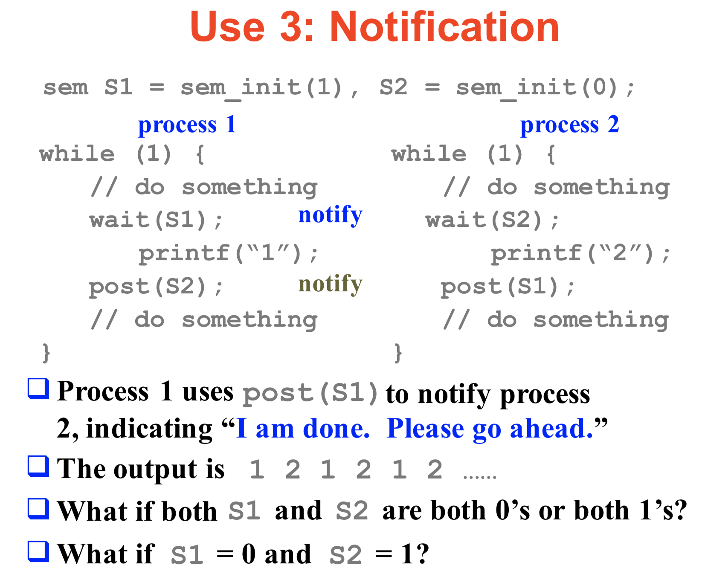

**Dining Philosophers With Semaphors**

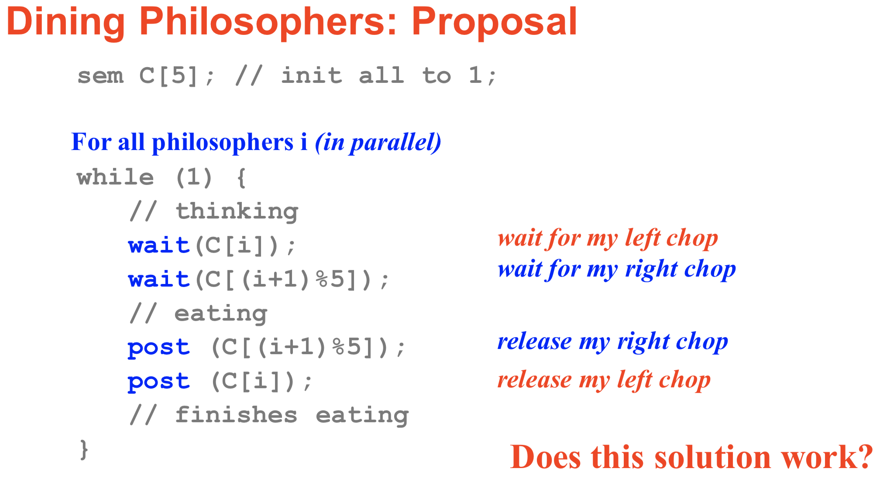

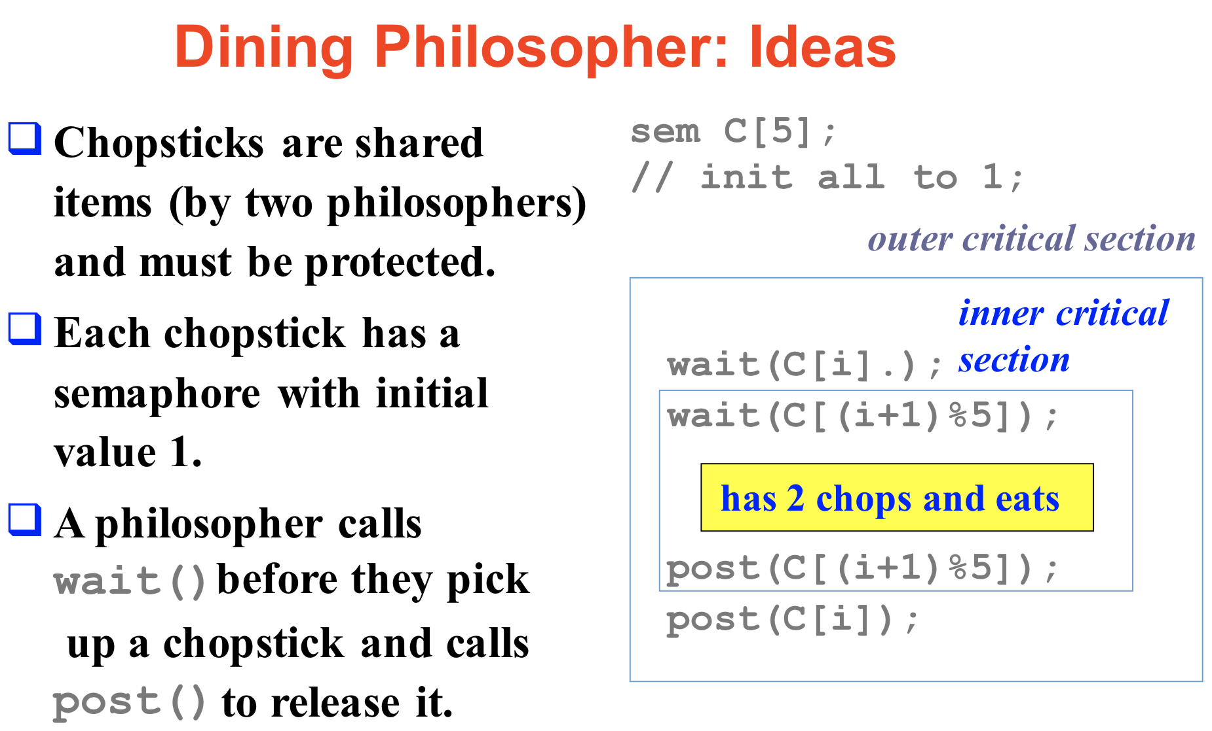

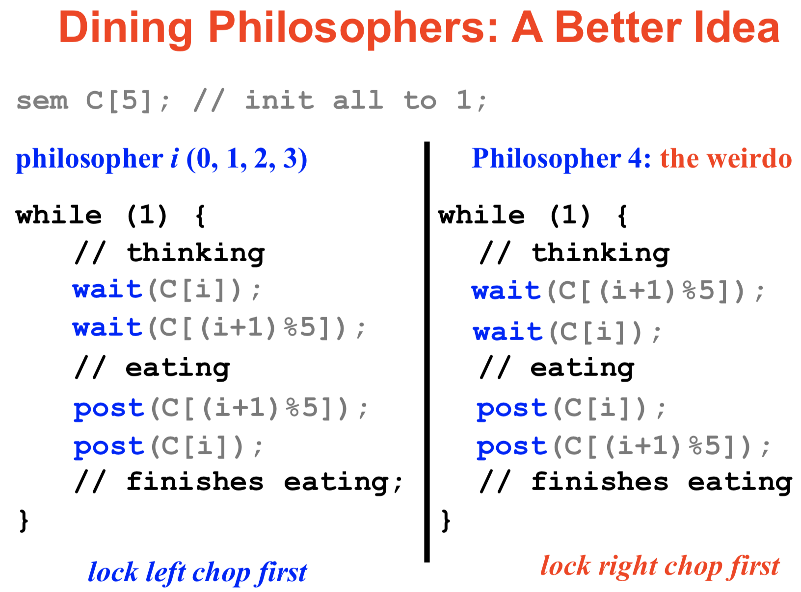

* We choose philosopher 4 to be the weirdo. Does this choice matter?
* Show that this solution does not cause circular waiting.
* Show that this solution will not have circular waiting if we have more than 1 and less than 5 weirdoes.

[Semaphores in C/Linux]

* Functionality included in:

#include <semaphore.h>

#include <fcntl.h>

* Sits on top of the system call semctl()

